**安装包**

npm install react-native-fs --save

**Link**

react-native link react-native-fs

**简单示例**

再assets目录下添加一个文件config.json

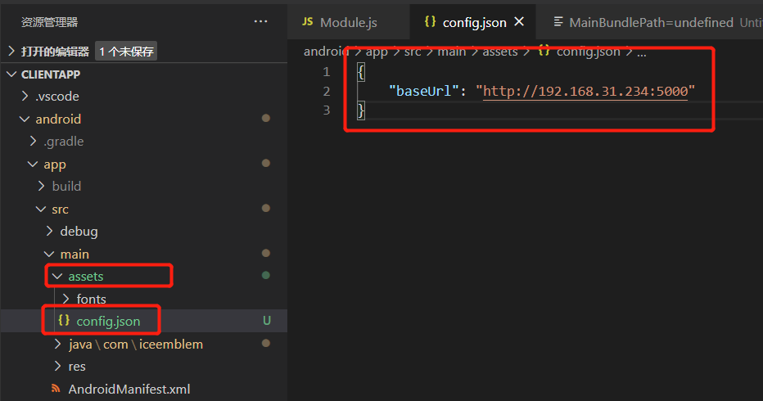

读取文件

import RNFS from 'react-native-fs';

RNFS.readFileAssets('config.json').then((result) => {

    let config = JSON.parse(result);

    setBaseUrl(config.baseUrl);

})

**可读写的文件目录**

插件提供了如下可读写目录

        console.log('MainBundlePath=' + RNFS.MainBundlePath)

        console.log('CachesDirectoryPath=' + RNFS.CachesDirectoryPath)

        console.log('DocumentDirectoryPath=' + RNFS.DocumentDirectoryPath)

        console.log('TemporaryDirectoryPath=' + RNFS.TemporaryDirectoryPath)

        console.log('LibraryDirectoryPath=' + RNFS.LibraryDirectoryPath)

        console.log('ExternalDirectoryPath=' + RNFS.ExternalDirectoryPath)

        console.log('ExternalStorageDirectoryPath=' + RNFS.ExternalStorageDirectoryPath)

安卓输出如下

MainBundlePath=undefined

CachesDirectoryPath=/data/data/com.iceemblem/cache

DocumentDirectoryPath=/data/data/com.iceemblem/files

TemporaryDirectoryPath=/data/data/com.iceemblem/cache

LibraryDirectoryPath=undefined

ExternalDirectoryPath=/storage/emulated/0/Android/data/com.iceemblem/files

ExternalStorageDirectoryPath=/storage/emulated/0

**基本Api**

读取目录

RNFS.readDir(RNFS.MainBundlePath)

    .then((result) => {

        console.log('GOT RESULT', result);

    })

文件创建

RNFS.writeFile(path, 'Lorem ipsum dolor sit amet', 'utf8')

    .then((success) => {

        console.log('FILE WRITTEN!');

    })

文件删除

RNFS.unlink(path)

    .then(() => {

        console.log('FILE DELETED');

    })

更多Api：https://github.com/itinance/react-native-fs